

Economics

SAC 3.1 UNIT 3 OUTCOME 1 PRACTICE

2022
You will have 60 minutes to complete this task plus 5 minutes reading time

Teacher: Mr. Daniel Charles/Ms. Hubbard

The total SAC contributes to 40/100 of SAC marks allocated for Unit 3.

Allowed materials for this task include:
- Pens, pencils, rulers, erasers, highlighters

Name ___________________________________________

Note: The grade or score for this task is only part of the internal assessment for this Unit. Your total School-assessed Coursework score may change as a result of statistical moderation by VCAA.

Grade/Score: ______ Satisfactory Completion? S/N: ______
(Provisional)

VCE ECONOMICS
SCHOOL-ASSESSED COURSEWORK
Performance Descriptors
Unit 4  Outcome 2  Discuss the nature and operation of aggregate supply policies and analyse how the policies may influence the Australian Government’s domestic macroeconomic goals and living standards. | DESCRIPTOR: typical performance in each range
 | Very low | Low | Medium | High | Very high
 | The discussion demonstrates limited knowledge and understanding of the nature and purpose of aggregate supply policies. | Some elementary discussion which demonstrates some knowledge and understanding of the nature and purpose of aggregate supply policies. | The discussion demonstrates satisfactory knowledge and understanding of the nature and purpose of aggregate supply policies. | The discussion is generally well developed and demonstrates sound knowledge and understanding of the nature and purpose of aggregate supply policies. | The discussion is very thorough and demonstrates detailed knowledge and understanding of the nature and purpose of aggregate supply policies.
 | Very little analysis lacks clarity and demonstrates limited knowledge and understanding of how aggregate supply policies have been implemented to influence Australia’s domestic macroeconomic goals and living standards. | Basic analysis with some factors identified which demonstrates some knowledge and understanding of how aggregate supply policies have been implemented to influence Australia’s domestic macroeconomic goals and living standards. | Satisfactory analysis which generally demonstrates adequate knowledge and understanding of how aggregate supply policies have been implemented to influence Australia’s domestic macroeconomic goals and living standards. | The analysis is generally well developed and demonstrates sound knowledge and understanding of how aggregate supply policies have been implemented to influence Australia’s domestic macroeconomic goals and living standards. | The analysis is comprehensive and demonstrates very thorough knowledge and understanding of how aggregate supply policies have been implemented to influence Australia’s domestic macroeconomic goals and living standards.
 | Limited use and application of economics terms, concepts, theories and data in the discussion and analysis. Little or no use of relevant data and evidence to support discussion and analysis.  Little use of specialist economics terms and vocabulary. | Some accurate application of knowledge and use of specialist economic terms, concepts and theories. Some reference to relevant data and evidence but not always applied appropriately. | Satisfactory selection, use and application of economics terms, concepts, theories, data and evidence to support the discussion and analysis. | Accurate definition, use and application of economics terms, concepts and theories. Sound use of relevant data and evidence to support the discussion and analysis. | Confident and accurate definition, use and application of economics terms, concepts and theories. Sophisticated use of relevant data and evidence to support the discussion and analysis.
 | Generally very little analysis and understandings of economic relationships. Reasoning and interpretation lacks clarity. Little evidence of an ability to synthesise arguments or draw appropriate conclusions. | Some understanding of economic relationships with some relevant conclusions. Limited use of relevant evidence, synthesis of arguments and logical economic reasoning. | Generally satisfactory analysis of the interrelatedness of economic relationships demonstrating adequate economic reasoning and interpretation. Some ability to synthesise the arguments presented and draw relevant conclusions. | Generally thorough analysis of the interrelatedness of economic relationships demonstrating sound economic reasoning and interpretation. An ability to synthesise arguments and draw conclusions is mostly well developed. | Very thorough and logical analysis of the interrelatedness of economic relationships demonstrating highly developed skills of economic reasoning and interpretation. Sophisticated ability to synthesise arguments and draw conclusions.

Section A: Multiple Choice (7 questions worth 1 mark each)

Question 1
In early 2020, the economic effects of the coronavirus included a surge in the price of hand sanitisers as the shortages developed in markets. In terms of demand and supply analysis on the market for hand sanitisers, this is represented by:

- A shift to the right of the supply curve and a movement along (expansion) the demand curve
- A shift to the left of the supply curve and a movement along (contraction) the demand curve
- A shift to the left of the demand curve and a movement along (contraction) the supply curve
- A shift to the right of the demand curve and a movement along (expansion) the supply curve

Question 2

Conservation programs to restore shellfish reefs in Port Phillip Bay and create a healthier, cleaner bay with more fish will most likely increase which type of efficiency?

- Allocative
- Dynamic
- Intertemporal
- Productive

Question 3
An expansion of quantity supplied would be shown graphically as:
- A shift to the left of the supply curve
- A shift to the right of the supply curve
- A movement up the supply curve
- A movement down the supply curve

Question 4
In the market for bikes, the equilibrium quantity would increase and the equilibrium price would decrease if:
A. increasing number of Australians choose to ride a bike during the COVID-19 restrictions.
B. there was a reduction in the cost of aluminium used in the production of bikes.
C. there are delays in the supply chain for the importing of bikes into Australia.
D. Australia’s population growth rate slows in 2020.

Question 5

Which of the following is most likely to increase the price elasticity of supply for new motor vehicles?

- There is a reduction in productive capacity following a shortage of important computer chips used in their production
- There is a decrease in the availability of substitutes such as motorcycles and public transport
- There is an increase in industrial disputes which is impacting on the ability to meet vehicle production deadlines
- The robotics used manufacturing plants has been upgraded, which has raised productivity and technical efficiency in the production of motor vehicles.

Question 6
In the event good A is a complement to good B, an increase in the price of good B is likely to:
- Increase demand for good A, causing the demand curve to shift to the left.
- Decrease demand for good A, causing the demand curve to shift to the right.
- Increase demand for good A, causing the demand curve to shift to the right.
- Decrease demand for good A, causing the demand curve to shift to the left.

Question 7
Which of the following statements is most correct in relation to public goods?
- Each additional user of a public good affects the amount available to others.
- Private companies supply public goods because they make a profit from them.
- Anyone can benefit from using public goods without paying directly for them.
- Low-income earners are disadvantaged because they cannot afford public goods

Section B – Short answer questions (4 questions - 33 marks)
Question 1
a. Outline two characteristics of a perfectly competitive market.
2 marks
__________________________________________________________________________________________________________________________________________________________________________________________________________________________________________________________________________________________________________________________________________________________________________________________________________________________
b. Explain how a perfectly competitive market allocates society’s scarce resources.
4 marks
____________________________________________________________________________________________________________________________________________________________________________________________________________________________________________________________________________________________________________________________________________________________________________________________________________________________________________________________________________________________________________________________________________________________________________________________________________________________________________________________________________________________________________________________________________________________________________________________________________________________________________________________________________________________________________________________________________________________________________________________________________________________________________________________________________________________________________________________________________________________________________________________
Question 2
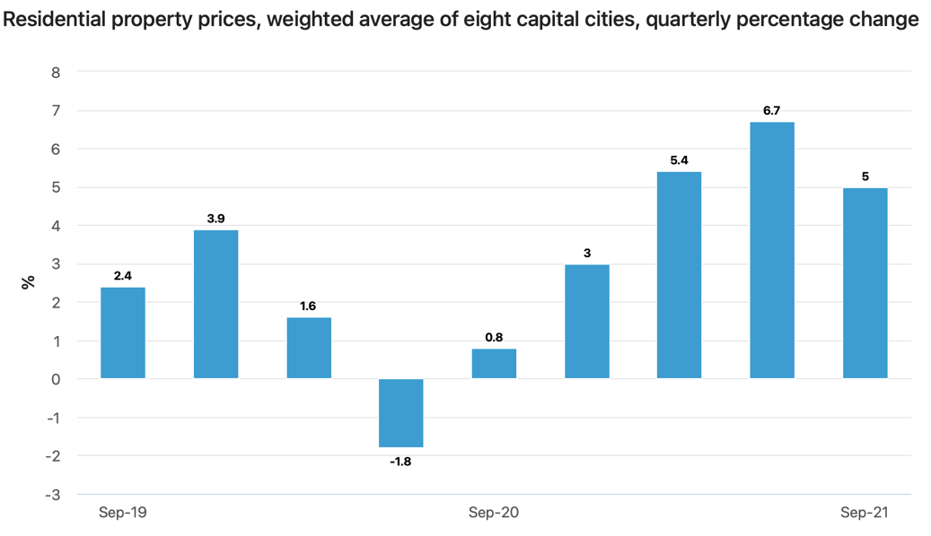
a. Outline one microeconomic demand-side factor and one microeconomic supply-side factor that might explain the trend in property prices since September 2020.
4 marks
______________________________________________________________________________________________________________________________________________________________________________________________________________________________________________________________________________________________________________________________________________________________________________________________________________________________________________________________________________________________________________________________________________________________________________________________________________________________________________________________________________________________________________________________________________________________________________________________________________________________________________________________________________________________________________________________________

b. Define price elasticity of demand and explain whether the price elasticity of demand for houses would be low (inelastic) or high (elastic).
3 marks
__________________________________________________________________________________________________________________________________________________________________________________________________________________________________________________________________________________________________________________________________________________________________________________________________________________________________________________________________________________________________________________________________________________________________________________________________________________________________________________________________________________________________________________________________________________________________

a. Identify and explain one type of market failure that can occur in a free and competitive market.
4 marks
____________________________________________________________________________________________________________________________________________________________________________________________________________________________________________________________________________________________________________________________________________________________________________________________________________________________________________________________________________________________________________________________________________________________________________________________________________________________________________________________________________________________________________________________________________________________________________________________________________________________________________________________________________________________________________________________________________________________________________________________________________________________________________________________________________________________________________________________________________________________________________________________

b. Evaluate the role of markets in achieving allocative efficiency. In your answer, refer to market failure.
6 marks
________________________________________________________________________________________________________________________________________________________________________________________________________________________________________________________________________________________________________________________________________________________________________________________________________________________________________________________________________________________________________________________________________________________________________________________________________________________________________________________________________________________________________________________________________________________________________________________________________________________________________________________________________________________________________________________________________________________________________________________________________________________________________________________________________________________________________________________________________________________________________________________________________________________________________________________________________________________________________________________________________________________________________________________________________________________________________________________________________________________________________________________________________________________________________________________________________________________________________________________________________________________________________________________________________________________________________________________________________________________________________________________________________________________________________________________________________________________________________________________________________________________________________________c. Using a fully labelled demand and supply diagram, explain how the Australian Government could correct a market failure.
6 marks

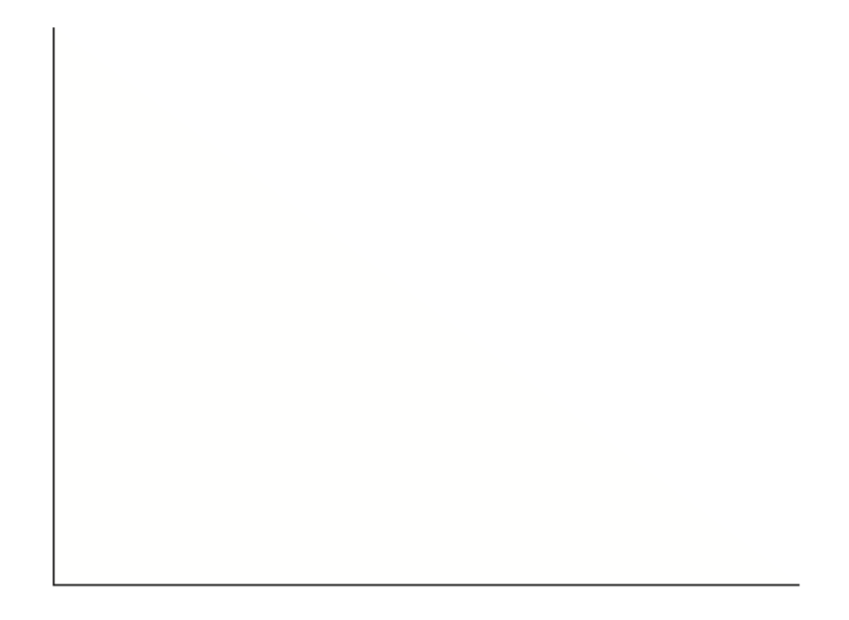
____________________________________________________________________________________________________________________________________________________________________________________________________________________________________________________________________________________________________________________________________________________________________________________________________________________________________________________________________________________________________________________________________________________________________________________________________________________________________________________________________________________________________________________________________________________________________________________________________________________________________________________________________________________________________________________________________________________________________________________________________________________________________________________________________________________________________________________________________________________________________________________________
Question 4
Outline one contemporary example of when government intervention unintentionally led to a misallocation of society’s scarce resources.
4 marks
________________________________________________________________________________________________________________________________________________________________________________________________________________________________________________________________________________________________________________________________________________________________________________________________________________________________________________________________________________________________________________________________________________________________________________________________________________________________________________________________________________________________________________________________________________________________________________________________________________________________________________________________________________________________________________________________________________________________________________________________________________________________________________________________________________________________________________________________________________________________________________________________________________________________________________________________________________________________________________________________________________________________

Extra writing space
____________________________________________________________________________________________________________________________________________________________________________________________________________________________________________________________________________________________________________________________________________________________________________________________________________________________________________________________________________________________________________________________________________________________________________________________________________________________________________________________________________________________________________________________________________________________________________________________________________________________________________________________________________________________________________________________________________________________________________________________________________________________________________________________________________________________________________________________________________________________________________________________________________________________________________________________________________________________________________________________________________________________________________________________________________________________________________________________________________________________________________________________________________________________________________________________________________________________________________________________________________________________________________________________________________________________________________________________________________________________________________________________________________________________________________________________________________________________________________________________________________________________________________________________________________________________________________________________________________________________________________________________________________________

